3GPP TS 29.554 V15.2.0 (2018-12)
Technical Specification
3rd Generation Partnership Project;
Technical Specification Group Core Network and Terminals;
5G System; Background Data Transfer Policy Control Service;
Stage 3
(Release 15)


The present document has been developed within the 3rd Generation Partnership Project (3GPP TM) and may be further elaborated for the purposes of 3GPP.
The present document has not been subject to any approval process by the 3GPP Organizational Partners and shall not be implemented.
This Specification is provided for future development work within 3GPP only. The Organizational Partners accept no liability for any use of this Specification.
Specifications and Reports for implementation of the 3GPP TM system should be obtained via the 3GPP Organizational Partners' Publications Offices.

Keywords

3GPP
Postal address

3GPP support office address
650 Route des Lucioles - Sophia Antipolis
Valbonne - FRANCE
Tel.: +33 4 92 94 42 00 Fax: +33 4 93 65 47 16
Internet
http://www.3gpp.org
Copyright Notification
No part may be reproduced except as authorized by written permission.
The copyright and the foregoing restriction extend to reproduction in all media.

© 2018, 3GPP Organizational Partners (ARIB, ATIS, CCSA, ETSI, TSDSI, TTA, TTC).
All rights reserved.

UMTS™ is a Trade Mark of ETSI registered for the benefit of its members
3GPP™ is a Trade Mark of ETSI registered for the benefit of its Members and of the 3GPP Organizational Partners
LTE™ is a Trade Mark of ETSI registered for the benefit of its Members and of the 3GPP Organizational Partners
GSM® and the GSM logo are registered and owned by the GSM Association
Contents
Foreword 5
1 Scope 6
2 References 6
3 Definitions and abbreviations 7
3.1 Definitions 7
3.2 Abbreviations 7
4 Background Data Transfer Policy Control Service 8
4.1 Service Description 8
4.1.1 Overview 8
4.1.2 Service Architecture 8
4.1.3 Network Functions 9
4.1.3.1 Policy Control Function (PCF) 9
4.1.3.2 NF Service Consumers 9
4.2 Service Operations 9
4.2.1 Introduction 9
4.2.2 Npcf_BDTPolicyControl_Create service operation 9
4.2.2.1 General 9
4.2.2.2 Retrieval of BDT policies 10
4.2.3 Npcf_BDTPolicyControl_Update service operation 11
4.2.3.1 General 11
4.2.3.2 Indication about selected transfer policy 11
5 Npcf_BDTPolicyControl API 12
5.1 Introduction 12
5.2 Usage of HTTP 13
5.2.1 General 13
5.2.2 HTTP standard headers 13
5.2.2.1 General 13
5.2.2.2 Content type 13
5.2.3 HTTP custom headers 13
5.3 Resources 14
5.3.1 Resource Structure 14
5.3.2 Resource: BDT policies (Collection) 14
5.3.2.1 Description 14
5.3.2.2 Resource definition 14
5.3.2.3 Resource Standard Methods 15
5.3.2.3.1 POST 15
5.3.2.4 Resource Custom Operations 15
5.3.3 Resource: Individual BDT policy (Document) 15
5.3.3.1 Description 15
5.3.3.2 Resource definition 15
5.3.3.3 Resource Standard Methods 16
5.3.3.3.1 GET 16
5.3.3.3.2 PATCH 16
5.4 Custom Operations without associated resources 17
5.5 Notifications 17
5.6 Data Model 17
5.6.1 General 17
5.6.2 Structured data types 18
5.6.2.1 Introduction 18
5.6.2.2 Type BdtPolicy 18
5.6.2.3 Type BdtReqData 19
5.6.2.4 Type BdtPolicyData 19
5.6.2.5 Type TransferPolicy 20
5.6.2.6 Type BdtPolicyDataPatch 20
5.6.2.7 Void 20
5.6.2.8 Type NetworkAreaInfo 20
5.6.2.9 Void 20
5.6.3 Simple data types and enumerations 20
5.6.3.1 Introduction 20
5.6.3.2 Simple data types 21
5.7 Error handling 21
5.7.1 General 21
5.7.2 Protocol Errors 21
5.7.3 Application Errors 21
5.8 Feature negotiation 21
5.9 Security 22
Annex A (normative): OpenAPI specification 22
A.1 General 22
A.2 Npcf_BDTPolicyControl API 22
Annex B (informative): Change history 27

Foreword
This Technical Specification has been produced by the 3rd Generation Partnership Project (3GPP).
The contents of the present document are subject to continuing work within the TSG and may change following formal TSG approval. Should the TSG modify the contents of the present document, it will be re-released by the TSG with an identifying change of release date and an increase in version number as follows:
Version x.y.z
where:
x the first digit:
1 presented to TSG for information;
2 presented to TSG for approval;
3 or greater indicates TSG approved document under change control.
y the second digit is incremented for all changes of substance, i.e. technical enhancements, corrections, updates, etc.
z the third digit is incremented when editorial only changes have been incorporated in the document.

1 Scope
The present specification provides the stage 3 definition of the Background Data Transfer (BDT) Policy Control Service (Npcf_BDTPolicyControl) of the 5G System.
The 5G System Architecture is defined in 3GPP TS 23.501 [2]. The stage 2 definition and related procedures for BDT Policy Control Service are specified in 3GPP TS 23.502 [3] and 3GPP TS 23.503 [4].
The 5G System stage 3 call flows are provided in 3GPP TS 29.513 [5].
The Technical Realization of the Service Based Architecture and the Principles and Guidelines for Services Definition are specified in 3GPP TS 29.500 [6] and 3GPP TS 29.501 [7].
The Policy Control Function (PCF) provides the BDT Policy Control Service. This service provides background data transfer policy negotiation function.

2 References
The following documents contain provisions which, through reference in this text, constitute provisions of the present document.
- References are either specific (identified by date of publication, edition number, version number, etc.) or non-specific.
- For a specific reference, subsequent revisions do not apply.
- For a non-specific reference, the latest version applies. In the case of a reference to a 3GPP document (including a GSM document), a non-specific reference implicitly refers to the latest version of that document in the same Release as the present document.
[1] 3GPP TR 21.905: "Vocabulary for 3GPP Specifications".
[2] 3GPP TS 23.501: "System Architecture for the 5G System; Stage 2".
[3] 3GPP TS 23.502: "Procedures for the 5G System; Stage 2".
[4] 3GPP TS 23.503: "Policy and Charging Control Framework for the 5G System; Stage 2".
[5] 3GPP TS 29.513: "5G System; Policy and Charging Control signalling flows and QoS parameter mapping; Stage 3".
[6] 3GPP TS 29.500: "5G System; Technical Realization of Service Based Architecture; Stage 3".
[7] 3GPP TS 29.501: "5G System; Principles and Guidelines for Services Definition; Stage 3".
[8] IETF RFC 7540: "Hypertext Transfer Protocol Version 2 (HTTP/2)".
[9] IETF RFC 8259: "The JavaScript Object Notation (JSON) Data Interchange Format".
[10] OpenAPI: "OpenAPI 3.0.0 Specification", https://github.com/OAI/OpenAPI-Specification/blob/master/versions/3.0.0.md.
[11] 3GPP TS 29.504: "5G System; Unified Data Repository Services; Stage 3".
[12] 3GPP TS 29.519: "5G System; Usage of the Unified Data Repository service for Policy Data, Application Data and Structured Data for exposure; Stage 3".
[13] 3GPP TS 29.571: "5G System; Common Data Types for Service Based Interfaces; Stage 3".
[14] 3GPP TS 29.122: "T8 reference point for Northbound APIs".
[15] IETF RFC 7396: "JSON Merge Patch".
[16] IETF RFC 3986: "Uniform Resource Identifier (URI): Generic Syntax".
[17] IETF RFC 7807: "Problem Details for HTTP APIs".
[18] 3GPP TS 33.501: "Security architecture and procedures for 5G system".
[19] IETF RFC 6749: "The OAuth 2.0 Authorization Framework".
[20] 3GPP TS 29.510: "5G System; Network Function Repository Services; Stage 3".

3 Definitions and abbreviations

3.1 Definitions
For the purposes of the present document, the terms and definitions given in 3GPP TR 21.905 [1] and the following apply. A term defined in the present document takes precedence over the definition of the same term, if any, in 3GPP TR 21.905 [1].
Background data transfer: feature that enables a 3rd party service provider to keep their costs lower by favouring time windows for data transfer to specific UEs in a geographical area during non-busy hours that are less costly and able to handle larger bitrates.
For the purposes of the present document, the following terms and definitions given in 3GPP TS 23.501 [2], subclause 3.1 apply:
5G System
Network Function
NF service
NF service operation
Service based interface

3.2 Abbreviations
For the purposes of the present document, the abbreviations given in 3GPP TR 21.905 [1] and the following apply. An abbreviation defined in the present document takes precedence over the definition of the same abbreviation, if any, in 3GPP TR 21.905 [1].
AF Application Function
ASP Application Service Provider
BDT Background Data Transfer
JSON JavaScript Object Notation
NEF Network Exposure Function
NG-RAN Next Generation - Radio Access Network
NRF Network Repository Function
PCF Policy Control Function
SBI Service Based Interface
TAI Tracking Area Identity
UDR Unified Data Repository

4 Background Data Transfer Policy Control Service

4.1 Service Description

4.1.1 Overview
The BDT Policy Control Service, as defined in 3GPP TS 23.502 [3] and 3GPP TS 23.503 [4], is provided by the Policy Control Function (PCF).
This service enables the NF service consumer to negotiate policy for a future background data transfer and offers the following functionalities:
- get background data transfer policies based on the request from the NEF; and
- update background data transfer policies based on the selection provided by the NEF.

4.1.2 Service Architecture
The 5G System Architecture is defined in 3GPP TS 23.501 [2]. The Policy and Charging related 5G architecture is also described in 3GPP TS 29.513 [5].
The BDT Policy Control Service (Npcf_BDTPolicyControl) is part of the Npcf service-based interface exhibited by the Policy Control Function (PCF).
The only known NF service consumer of the Npcf_BDTPolicyControl service is the Network Exposure Function (NEF).
The NEF accesses the BDT Policy Control Service at the PCF via the N30 Reference point. In the roaming scenario, the N30 reference point is located between the PCF and the NEF in the home network only.
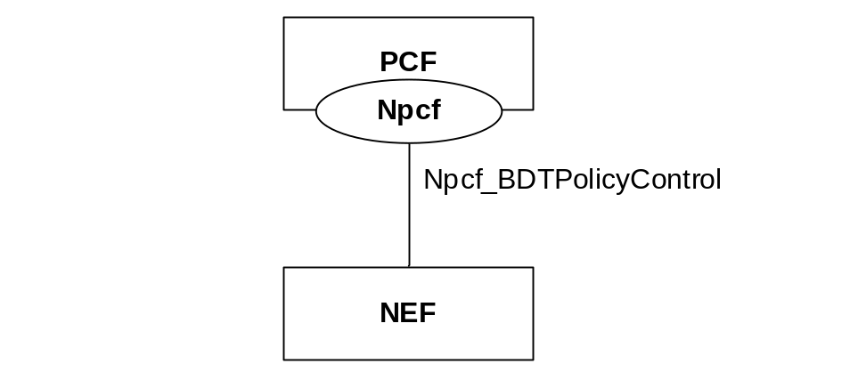
Figure 4.1.2-1: Reference Architecture for the Npcf_BDTPolicyControl Service; SBI representation
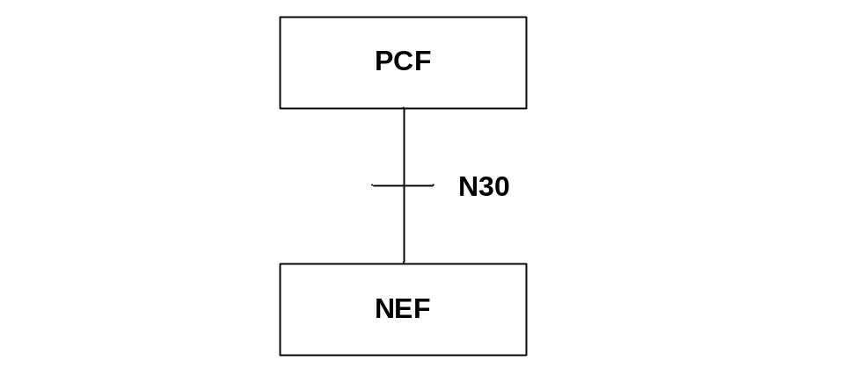
Figure 4.1.2-2: Reference Architecture for the Npcf_BDTPolicyControl Service; reference point representation

4.1.3 Network Functions

4.1.3.1 Policy Control Function (PCF)
The Policy Control Function (PCF):
- Provides background data transfer policies based on the request from the NEF. The PCF determines, based on information provided by the NEF and other available information (e.g. network policy, load status estimation for the requested time window, network area, etc.) one or more transfer policies.
- Updates background data transfer policy based on the selection provided by the NEF.

4.1.3.2 NF Service Consumers
The Network Exposure Function (NEF):
- requests the PCF to provide background data transfer policies; and
- provides the selected background data transfer policy to the PCF.

4.2 Service Operations

4.2.1 Introduction
Table 4.2.1-1: Operations of the Npcf_BDTPolicyControl Service
Service operation name | Description | Initiated by
Npcf_BDTPolicyControl_Create | Provides the requested background data transfer policies to the NF service consumer. | NF service consumer (NEF)
Npcf_BDTPolicyControl_Update | Updates the PCF with the background data transfer policy selected by the NF service consumer. | NF service consumer (NEF)

4.2.2 Npcf_BDTPolicyControl_Create service operation

4.2.2.1 General
The Npcf_BDTPolicyControl_Create service operation is used by an NF service consumer to retrieve BDT policies from the PCF.
The following procedure using the Npcf_BDTPolicyControl_Create service operation is supported:
- retrieval of BDT policies.

4.2.2.2 Retrieval of BDT policies
This procedure is used by the NEF to request BDT policies from the PCF, as defined in 3GPP TS 23.501 [2], 3GPP TS 23.502 [3] and 3GPP TS 23.503 [4].
Figure 4.2.2.2-1 illustrates a retrieval of BDT policies.
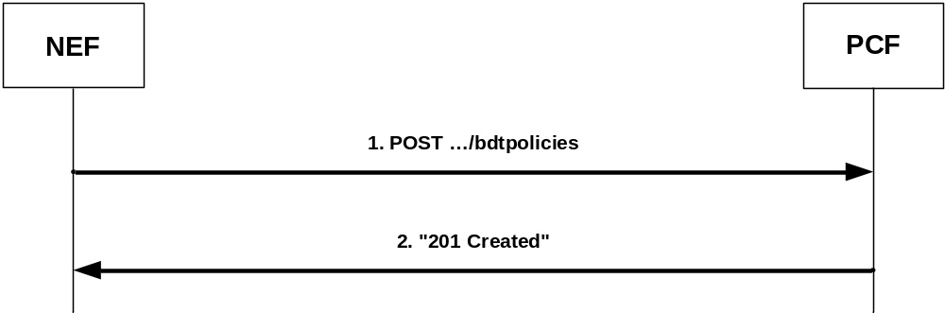
Figure 4.2.2.2-1: Retrieval of BDT policies
Upon reception of a Background Data Transfer request from the AF indicating a transfer policy request, the NEF shall invoke the Npcf_BDTPolicyControl_Create service operation by sending an HTTP POST request to the URI representing a "BDT policies" collection resource of the PCF (as shown in figure 4.2.2.2-1, step 1). The NEF shall include a "BdtReqData" data type in a payload body of the HTTP POST request. The "BdtReqData" data type shall contain:
- an ASP identifier in the "aspId" attribute;
- a volume of data per UE in the "volPerUe" attribute;
- an expected number of UEs in the "numOfUes" attribute; and
- a desired time window in the "desTimeInt" attribute,
and may include a network area information (e.g. list of TAIs and/or NG-RAN nodes and/or cells identifiers) in the "nwAreaInfo" attribute.
If the PCF cannot successfully fulfil the received HTTP POST request due to the internal PCF error or due to the error in the HTTP POST request, the PCF shall send the HTTP error response as specified in subclause 5.7.
Otherwise, upon the reception of the HTTP POST request from the NEF indicating a BDT policies request, the PCF:
- may invoke the Nudr_DataRepository_Query service operation, as described in 3GPP TS 29.504 [11] and 3GPP TS 29.519 [12], to request from the UDR all stored transfer policies;
NOTE 1: In case only one PCF is deployed in the network, transfer policies can be locally stored in the PCF and the interaction with the UDR is not required.
- shall determine one or more acceptable transfer policies based on:
a) information provided by the NEF; and
b) other available information (e.g. the existing transfer policies, network policy, load status estimation for the desired time window); and
- shall create a BDT Reference ID.
The PCF shall send to the NEF a "201 Created" response to the HTTP POST request, as shown in figure 4.2.2.2-1, step 2. The PCF shall include in the "201 Created" response:
- a Location header field; and
- a "BdtPolicy" data type in the payload body containing the BDT Reference ID in the "bdtRefId" attribute and acceptable transfer policy/ies in the "transfPolicies" attribute.
The Location header field shall contain the URI of the created individual BDT policy resource i.e. "{apiRoot}/npcf-bdtpolicycontrol/v1/bdtpolicies/{bdtPolicyId}".
For each included transfer policy, the PCF shall provide:
- a transfer policy ID in the "transPolicyId" attribute;
- a recommended time window in the "recTimeInt" attribute; and
- a reference to charging rate for the recommended time window in the "ratingGroup" attribute,
and may provide a maximum aggregated bitrate for the uplink direction in the "maxBitRateUl" attribute and/or a maximum aggregated bitrate for the downlink direction in the "maxBitRateDl" attribute.
If the PCF included in the "BdtPolicy" data type:
- more than one transfer policy, the PCF shall wait for the transfer policy selected by the NEF as described in subclause 4.2.3; or
- only one transfer policy, the PCF may invoke the Nudr_DataRepository_Update service operation, as described in 3GPP TS 29.504 [11] and 3GPP TS 29.519 [12], to update the UDR with the selected transfer policy and the corresponding BDT Reference ID for the provided ASP identifier.
NOTE 2: In case only one PCF is deployed in the network, transfer policies can be locally stored in the PCF and the interaction with the UDR is not required.

4.2.3 Npcf_BDTPolicyControl_Update service operation

4.2.3.1 General
The Npcf_BDTPolicyControl_Update service operation is used by an NF service consumer to update a BDT policy to the PCF.
The following procedure using the Npcf_BDTPolicyControl_Update service operation is supported:
- indication about selected transfer policy.

4.2.3.2 Indication about selected transfer policy
This procedure is used by the NEF to inform the PCF about selected transfer policy, as defined in 3GPP TS 23.501 [2], 3GPP TS 23.502 [3] and 3GPP TS 23.503 [4].
Figure 4.2.3.2-1 illustrates an indication about selected transfer policy.
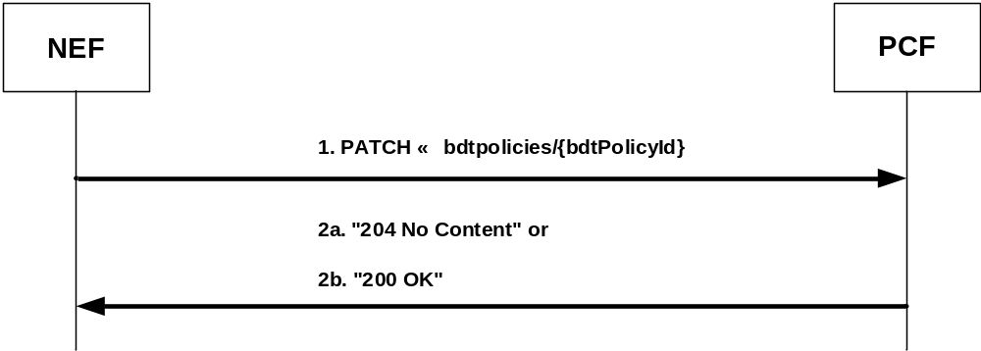
Figure 4.2.3.2-1: Indication about selected transfer policy
Upon reception of a Background Data Transfer request from the AF indicating transfer policy selection, the NEF shall invoke the Npcf_BDTPolicyControl_Update service operation by sending an HTTP PATCH request to the PCF, as shown in figure 4.2.3.2-1, step 1. The NEF shall set the request URI to "{apiRoot}/npcf-bdtpolicycontrol/v1/bdtpolicies/{bdtPolicyId}".
The NEF shall include a "BdtPolicyDataPatch" data type in a payload body of the HTTP PATCH request. The "BdtPolicyDataPatch" data type shall contain a transfer policy ID of the selected transfer policy in the "selTransPolicyId" attribute.
If the PCF cannot successfully fulfil the received HTTP PATCH request due to the internal PCF error or due to the error in the HTTP PATCH request, the PCF shall send the HTTP error response as specified in subclause 5.7.
Otherwise, upon the reception of the HTTP PATCH request from the NEF indicating a selected transfer policy, the PCF:
- may invoke the Nudr_DataRepository_Update service operation, as described in 3GPP TS 29.504 [11] and 3GPP TS 29.519 [12], to update the UDR with the modified information from the NEF;
NOTE: In case only one PCF is deployed in the network, transfer policies can be locally stored in the PCF and the interaction with the UDR is not required.
- shall send:
a) a "204 No Content" response (as shown in figure 4.2.3.2-1, step 2a); or
b) a "200 OK" response (as shown in figure 4.2.3.2-1, step 2b) with a "BdtPolicy" data type in the payload body,
to the HTTP PATCH request to the NEF.

5 Npcf_BDTPolicyControl API

5.1 Introduction
The BDT Policy Control Service shall use the Npcf_BDTPolicyControl API.
The request URI used in each HTTP request from the NF service consumer towards the PCF shall have the structure defined in subclause 4.4.1 of 3GPP TS 29.501 [7], i.e.:
{apiRoot}/{apiName}/{apiVersion}/{apiSpecificResourceUriPart}
with the following components:
- The {apiRoot} shall be set as described in 3GPP TS 29.501 [7].
- The {apiName} shall be "npcf-bdtpolicycontrol".
- The {apiVersion} shall be "v1".
- The {apiSpecificResourceUriPart} shall be set as described in subclause 5.3.

5.2 Usage of HTTP

5.2.1 General
HTTP/2, IETF RFC 7540 [8], shall be used as specified in subclause 5.2 of 3GPP TS 29.500 [6].
HTTP/2 shall be transported as specified in subclause 5.3 of 3GPP TS 29.500 [6].
The OpenAPI [10] specification of HTTP messages and content bodies for the Npcf_BDTPolicyControl is contained in Annex A.

5.2.2 HTTP standard headers

5.2.2.1 General
See subclause 5.2.2 of 3GPP TS 29.500 [6] for the usage of HTTP standard headers.

5.2.2.2 Content type
JSON, IETF RFC 8259 [9], shall be used as content type of the HTTP bodies specified in the present specification as specified in subclause 5.4 of 3GPP TS 29.500 [6]. The use of the JSON format shall be signalled by the content type "application/json".
JSON object used in the HTTP PATCH request shall be encoded according to "JSON Merge Patch" and shall be signalled by the content type "application/merge-patch+json", as defined in IETF RFC 7396 [15].
"Problem Details" JSON object shall be used to indicate additional details of the error in a HTTP response body and shall be signalled by the content type "application/problem+json", as defined in IETF RFC 7807 [17].

5.2.3 HTTP custom headers
The Npcf_BDTPolicyControl API shall support HTTP custom header fields specified in subclause 5.2.3.2 of 3GPP TS 29.500 [6].
In this Release of the specification, no specific custom headers are defined for the Npcf_BDTPolicyControl API.

5.3 Resources

5.3.1 Resource Structure
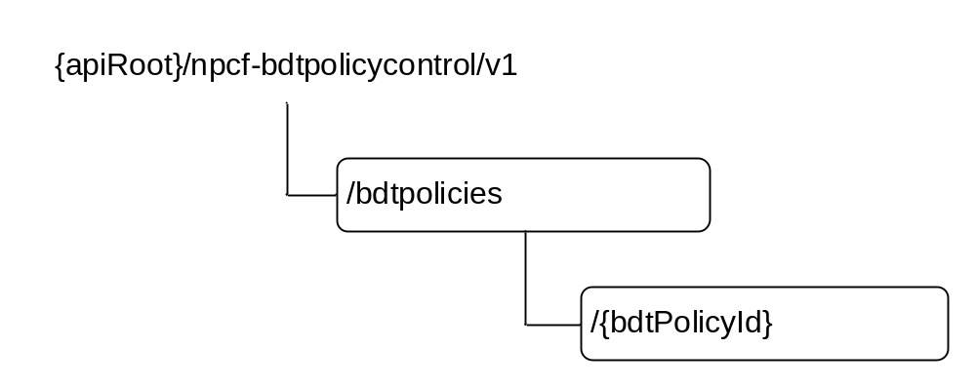
Figure 5.3.1-1: Resource URI structure of the Npcf_BDTPolicyControl API
Table 5.3.1-1 provides an overview of the resources and applicable HTTP methods.
Table 5.3.1-1: Resources and methods overview
Resource name | Resource URI | HTTP method or custom operation | Description
BDT policies | {apiRoot}/npcf-bdtpolicycontrol/v1/  bdtpolicies | POST | Npcf_BDTPolicyControl_Create. Creates a new Individual BDT policy resource.
Individual BDT policy | {apiRoot}/npcf-bdtpolicycontrol/v1/  bdtpolicies/{bdtPolicyId} | GET | Reads an Individual BDT policy resource.
Individual BDT policy |  | PATCH | Npcf_BDTPolicyControl_Update.  Modifies an existing Individual BDT policy resource by selecting or reselecting a transfer policy.

5.3.2 Resource: BDT policies (Collection)

5.3.2.1 Description
The BDT policies resource represents all the transfer policies that exist in the BDT Policy Control service at a given PCF instance.

5.3.2.2 Resource definition
Resource URI: {apiRoot}/npcf-bdtpolicycontrol/v1/bdtpolicies
This resource shall support the resource URI variables defined in table 5.3.2.2-1.
Table 5.3.2.2-1: Resource URI variables for this resource
Name | Definition
apiRoot | See subclause 5.1.

5.3.2.3 Resource Standard Methods

5.3.2.3.1 POST
This method shall support the URI query parameters specified in table 5.3.2.3.1-1.
Table 5.3.2.3.1-1: URI query parameters supported by the POST method on this resource
Name | Data type | P | Cardinality | Description
n/a

This method shall support the request data structures specified in table 5.3.2.3.1-2 and the response data structures and response codes specified in table 5.3.2.3.1-3.
Table 5.3.2.3.1-2: Data structures supported by the POST Request Body on this resource
Data type | P | Cardinality | Description
BdtReqData | M | 1 | Contains information for the creation of a new Individual BDT policy resource.

Table 5.3.2.3.1-3: Data structures supported by the POST Response Body on this resource
Data type | P | Cardinality | Response Codes | Description
BdtPolicy | M | 1 | 201 Created | Successful case.  The creation of an Individual BDT policy resource is confirmed and a representation of that resource is returned.
n/a |  |  | 303 See Other | The result of the HTTP POST request would be equivalent to the existing Individual BDT policy resource. The HTTP response shall contain a Location header field set to the URI of the existing individual BDT policy resource.
NOTE: In addition, the HTTP status codes which are specified as mandatory in table 5.2.7.1-1 of 3GPP TS 29.500 [6] for the POST method shall also apply.

5.3.2.4 Resource Custom Operations
None.

5.3.3 Resource: Individual BDT policy (Document)

5.3.3.1 Description
The Individual BDT policy resource represents the transfer policies that exist in the BDT Policy Control service at a given PCF instance.

5.3.3.2 Resource definition
Resource URI: {apiRoot}/npcf-bdtpolicycontrol/v1/bdtpolicies/{bdtPolicyId}
This resource shall support the resource URI variables defined in table 5.3.3.2-1.
Table 5.3.3.2-1: Resource URI variables for this resource
Name | Definition
apiRoot | See subclause 5.1.
bdtPolicyId | String identifying the individual BDT policy resource in the PCF.  To enable the value to be used as part of a URI, the string shall only contain allowed characters according to the "lower-with-hyphen" naming convention defined in subclause 5.1.3 of 3GPP TS 29.501 [7] and rules for a path segment defined in IETF RFC 3986 [16].

5.3.3.3 Resource Standard Methods

5.3.3.3.1 GET
This method shall support the URI query parameters specified in table 5.3.3.3.1-1.
Table 5.3.3.3.1-1: URI query parameters supported by the GET method on this resource
Name | Data type | P | Cardinality | Description
n/a

This method shall support the request data structures specified in table 5.3.3.3.1-2 and the response data structures and response codes specified in table 5.3.3.3.1-3.
Table 5.3.3.3.1-2: Data structures supported by the GET Request Body on this resource
Data type | P | Cardinality | Description
n/a

Table 5.3.3.3.1-3: Data structures supported by the GET Response Body on this resource
Data type | P | Cardinality | Response codes | Description
BdtPolicy | M | 1 | 200 OK | A representation of an Individual BDT policy resource is returned.
ProblemDetails | M | 1 | 404 Not Found | (NOTE 2)
NOTE 1: In addition, the HTTP status codes which are specified as mandatory in table 5.2.7.1-1 of 3GPP TS 29.500 [6] for the GET method shall also apply.
NOTE 2: Failure cases are described in subclause 5.7.

5.3.3.3.2 PATCH
This method shall support the URI query parameters specified in table 5.3.3.3.2-1.
Table 5.3.3.3.2-1: URI query parameters supported by the PATCH method on this resource
Name | Data type | P | Cardinality | Description
n/a

This method shall support the request data structures specified in table 5.3.3.3.2-2 and the response data structures and response codes specified in table 5.3.3.3.2-3.
Table 5.3.3.3.2-2: Data structures supported by the PATCH Request Body on this resource
Data type | P | Cardinality | Description
BdtPolicyDataPatch | M | 1 | Contains modification instructions to be performed on the BdtPolicy data structure to select a transfer policy.

Table 5.3.3.3.2-3: Data structures supported by the PATCH Response Body on this resource
Data type | P | Cardinality | Response Codes | Description
BdtPolicy | M | 1 | 200 OK | Successful case.  The Individual BDT Policy resource is modified and a representation of that resource is returned.
n/a |  |  | 204 No Content | Successful case.  The Individual BDT Policy resource is modified.
ProblemDetails | M | 1 | 404 Not Found | (NOTE 2)
NOTE 1: In addition, the HTTP status codes which are specified as mandatory in table 5.2.7.1-1 of 3GPP TS 29.500 [6] for the PATCH method shall also apply.
NOTE 2: Failure cases are described in subclause 5.7.

5.4 Custom Operations without associated resources
No custom operation is defined in this Release of the specification.

5.5 Notifications
Notifications are not applicable for the current Release.

5.6 Data Model

5.6.1 General
This subclause specifies the application data model supported by the API.
Table 5.6.1-1 specifies the data types defined for the Npcf_BDTPolicyControl service based interface protocol.
Table 5.6.1-1: Npcf_BDTPolicyControl specific Data Types
Data type | Section defined | Description | Applicability
BdtPolicy | 5.6.2.2 | Represents an Individual BDT policy resource.
BdtPolicyData | 5.6.2.4 | Describes an Individual BDT policy resource.
BdtPolicyDataPatch | 5.6.2.6 | Contains modification instructions to be performed on the BdtPolicy data structure to select a transfer policy.
BdtReqData | 5.6.2.3 | Contains information for creation a new Individual BDT policy resource.
NetworkAreaInfo | 5.6.2.8 | Describes a network area information in which the NF service consumer requests the number of UEs.
TransferPolicy | 5.6.2.5 | Describes a transfer policy.

Table 5.6.1-2 specifies data types re-used by the Npcf_BDTPolicyControl service based interface protocol from other specifications, including a reference to their respective specifications and when needed, a short description of their use within the Npcf_BDTPolicyControl service based interface.
Table 5.6.1-2: Npcf_BDTPolicyControl re-used Data Types
Data type | Reference | Comments | Applicability
BdtReferenceId | 3GPP TS 29.122 [14] | Identifies transfer policy of background data transfer for provided ASP.
BitRate | 3GPP TS 29.571 [13] | Specifies bitrate in kbits per second.
Ecgi | 3GPP TS 29.571 [13] | Represents an EUTRA cell identifier.
Ncgi | 3GPP TS 29.571 [13] | Represents an NR cell identifier.
GlobalRanNodeId | 3GPP TS 29.571 [13] | Represents an identity of the NG-RAN node.
ProblemDetails | 3GPP TS 29.571 [13] | Used in error responses to provide more detailed information about an error.
SupportedFeatures | 3GPP TS 29.571 [13] | Used to negotiate the applicability of the optional features defined in table 5.8-1.
Tai | 3GPP TS 29.571 [13] | Represents a tracking area identity.
TimeWindow | 3GPP TS 29.122 [14] | Specifies a time interval.
UsageThreshold | 3GPP TS 29.122 [14] | Represents a data volume expected to be transferred per UE.

5.6.2 Structured data types

5.6.2.1 Introduction
This subclause defines the structures to be used in resource representations.

5.6.2.2 Type BdtPolicy
Table 5.6.2.2-1: Definition of type BdtPolicy
Attribute name | Data type | P | Cardinality | Description | Applicability
bdtPolData | BdtPolicyData | C | 0..1 | Describes the authorization data of an Individual BDT Policy created by the PCF.  It shall be present in the response to the POST request that requests a creation of an Individual BDT Policy resource and in the response to GET request.
bdtReqData | BdtReqData | C | 0..1 | Identifies the service requirements of an Individual BDT Policy.  It shall be present in the POST request that requests a creation of an Individual BDT Policy resource and in the response to GET request.

5.6.2.3 Type BdtReqData
Table 5.6.2.3-1: Definition of type BdtReqData
Attribute name | Data type | P | Cardinality | Description | Applicability
aspId | AspId | M | 1 | This IE contains an identity of an application service provider.
desTimeInt | TimeWindow | M | 1 | This IE indicates a desired time window for BDT.
nwAreaInfo | NetworkAreaInfo | O | 0..1 | This IE represents a network area information in which the NF service consumer requests a number of UEs.  It may be present in the POST request that requests a creation of an Individual BDT Policy and in the response to GET request.
numOfUes | integer | M | 1 | This IE indicates a number of UEs.
suppFeat | SupportedFeatures | C | 0..1 | This IE represents a list of Supported features used as described in subclause 5.8.  It shall be supplied by the NF service consumer in the POST request that request a creation of an Individual BDT Policy resource.
volPerUe | UsageThreshold | M | 1 | This IE indicates a data volume expected to be transferred per UE.

5.6.2.4 Type BdtPolicyData
Table 5.6.2.4-1: Definition of type BdtPolicyData
Attribute name | Data type | P | Cardinality | Description | Applicability
bdtRefId | BdtReferenceId | M | 1 | This IE indicates transfer policies of background data transfer for provided ASP.
selTransPolicyId | integer | C | 0..1 | This IE contains the identity of the selected transfer policy.  It shall be present in the response to the PATCH request that modifies an Individual BDT Policy resource to indicate a selected transfer policy.
suppFeat | SupportedFeatures | C | 0..1 | This IE represents a list of Supported features used as described in subclause 5.8.  It shall be supplied by the PCF in the response to the POST request that requests a creation of an Individual BDT Policy resource.
transfPolicies | array(TransferPolicy) | M | 1..N | This IE contains transfer policies.  It shall be supplied by the PCF in the response to the POST request that requests a creation of an Individual BDT Policy resource.

5.6.2.5 Type TransferPolicy
Table 5.6.2.5-1: Definition of type TransferPolicy
Attribute name | Data type | P | Cardinality | Description | Applicability
maxBitRateDl | BitRate | O | 0..1 | This IE indicates a maximum aggregated bitrate in the downlink direction authorized by the PCF.
maxBitRateUl | BitRate | O | 0..1 | This IE indicates a maximum aggregated bitrate in the uplink direction authorized by the PCF.
ratingGroup | integer | M | 1 | This IE indicates a rating group for the recommended time window.
recTimeInt | TimeWindow | M | 1 | This IE indicates a recommended time window of a transfer policy.
transPolicyId | integer | M | 1 | This IE contains an identity of a transfer policy.

5.6.2.6 Type BdtPolicyDataPatch
Table 5.6.2.6-1: Definition of type BdtPolicyDataPatch
Attribute name | Data type | P | Cardinality | Description | Applicability
selTransPolicyId | integer | M | 1 | This IE contains an identity (i.e. the transPolicyId value) of a selected transfer policy.

5.6.2.7 Void

5.6.2.8 Type NetworkAreaInfo
Table 5.6.2.8-1: Definition of type NetworkAreaInfo
Attribute name | Data type | P | Cardinality | Description | Applicability
ecgis | array(Ecgi) | O | 1..N | This IE contains a list of E-UTRA cell identities.
ncgis | array(Ncgi) | O | 1..N | This IE contains a list of NR cell identities.
gRanNodeIds | array(GlobalRanNodeId) | O | 1..N | This IE contains a list of the NG-RAN nodes.  The "n3IwfId" attribute within the "GlobalRanNodeId" data type shall not be supplied.
tais | array(Tai) | O | 1..N | This IE contains a list of tracking area identities.
NOTE: The NetworkAreaInfo data type allows any combination of defined properties.

5.6.2.9 Void

5.6.3 Simple data types and enumerations

5.6.3.1 Introduction
This subclause defines simple data types and enumerations that can be referenced from data structures defined in the previous subclauses.

5.6.3.2 Simple data types
The simple data types defined in table 5.6.3.2-1 shall be supported.
Table 5.6.3.2-1: Simple data types
Type Name | Type Definition | Description | Applicability
AspId | string | This IE contains an identity of an application service provider.

5.7 Error handling

5.7.1 General
HTTP error handling shall be supported as specified in subclause 5.2.4 of 3GPP TS 29.500 [6].
For the Npcf_BDTPolicyControl API, HTTP error responses shall be supported as specified in subclause 4.8 of 3GPP TS 29.501 [7]. Protocol errors and application errors specified in table 5.2.7.2-1 of 3GPP TS 29.500 [6] shall be supported for an HTTP method if the corresponding HTTP status codes are specified as mandatory for that HTTP method in table 5.2.7.1-1 of 3GPP TS 29.500 [6]. In addition, the requirements in the following subclauses shall apply.

5.7.2 Protocol Errors
In this Release of the specification, there are no additional protocol errors applicable for the Npcf_BDTPolicyControl API.

5.7.3 Application Errors
The application errors defined for the Npcf_BDTPolicyControl API are listed in table 5.7.3-1. The PCF shall include in the HTTP status code a "ProblemDetails" data structure with the "cause" attribute indicating the application error as listed in table 5.7.3-1.
Table 5.7.3-1: Application errors
Application Error | HTTP status code | Description
BDT_POLICY_NOT_FOUND | 404 Not Found | The HTTP request is rejected because the specified Individual BDT policy resource does not exist. (NOTE)
NOTE: This application error is included in the responses to the GET and PATCH requests.

5.8 Feature negotiation
The optional features in table 5.8-1 are defined for the Npcf_BDTPolicyControl API. They shall be negotiated using the extensibility mechanism defined in subclause 6.6.2 of 3GPP TS 29.500 [6].
When requesting the PCF to create an Individual BDT policy resource the NF service consumer shall indicate the optional features the NF service consumer supports for the Npcf_BDTPolicyControl service by including the "suppFeat" attribute in the "BdtReqData" data type of the HTTP POST request.
The PCF shall determine the supported features for the created Individual BDT policy resource as specified in subclause 6.6.2 of 3GPP TS 29.500 [6]. The PCF shall indicate the supported features in the HTTP response confirming the creation of the Individual BDT policy resource by including the "suppFeat" attribute in the "BdtPolicyData" data type.
Table 5.8-1: Supported Features
Feature number | Feature Name | Description

5.9 Security
As indicated in 3GPP TS 33.501 [18] and 3GPP TS 29.500 [6], the access to the Npcf_BDTPolicyControl API, based on local configuration, may be authorized by means of the OAuth2 protocol (see IETF RFC 6749 [19]), using the "Client Credentials" authorization grant, where the NRF (see 3GPP TS 29.510 [20]) plays the role of the authorization server.
If OAuth2 authorization is used, an NF Service Consumer, prior to consuming services offered by the Npcf_BDTPolicyControl API, shall obtain a "token" from the authorization server, by invoking the Access Token Request service, as described in 3GPP TS 29.510 [20], subclause 5.4.2.2.
NOTE: When multiple NRFs are deployed in a network, the NRF used as authorization server is the same NRF that the NF Service Consumer used for discovering the Npcf_BDTPolicyControl service.
The Npcf_BDTPolicyControl API defines a single scope "npcf-bdtpolicycontrol" for OAuth2 authorization (as specified in 3GPP TS 33.501 [18]) for the entire API, and it does not define any additional scopes at resource or operation level.

Annex A (normative):
OpenAPI specification

A.1 General
The present Annex contains an OpenAPI [10] specification of HTTP messages and content bodies used by the Npcf_BDTPolicyControl API.
In case of conflicts between the main body of the present document and the present Annex, the information in the main body shall be applicable.

A.2 Npcf_BDTPolicyControl API
openapi: 3.0.0
info:
title: Npcf_BDTPolicyControl Service API
version: "1.0.0"
description: The Npcf_BDTPolicyControl Service is used by an NF service consumer to retrieve background data transfer policies from the PCF and to update the PCF with the background data transfer policy selected by the NF service consumer.
#
externalDocs:
description: 3GPP TS 29.554 V15.2.0; 5G System; Background Data Transfer Policy Control Service.
url: 'http://www.3gpp.org/ftp/Specs/archive/29_series/29.554/'
#
servers:
- url: '{apiRoot}/npcf-bdtpolicycontrol/v1'
variables:
apiRoot:
default: https://example.com
description: apiRoot as defined in subclause 4.4 of 3GPP TS 29.501.
security:
- {}
- oAuth2ClientCredentials:
- npcf-bdtpolicycontrol
paths:
/bdtpolicies:
post:
summary: Create a new Individual BDT policy
operationId: CreateBDTPolicy
tags:
- BDT policies (Collection)
requestBody:
description: Contains information for the creation of a new Individual BDT policy resource.
required: true
content:
application/json:
schema:
$ref: '#/components/schemas/BdtReqData'
responses:
'201':
description: Background data transfer policies offered to an ASP.
content:
application/json:
schema:
$ref: '#/components/schemas/BdtPolicy'
headers:
Location:
description: 'Contains the URI of the created individual BDT policy resource, according to the structure: {apiRoot}/npcf-bdtpolicycontrol/v1/bdtpolicies/{bdtPolicyId}'
required: true
schema:
type: string
#
# Error scenarios POST
#
'303':
description: See Other. The result of the POST request would be equivalent to the existing Individual BDT policy resource. The HTTP response shall contain a Location header field set to the URI of the existing individual BDT policy resource.
'400':
$ref: 'TS29571_CommonData.yaml#/components/responses/400'
'401':
$ref: 'TS29571_CommonData.yaml#/components/responses/401'
'403':
$ref: 'TS29571_CommonData.yaml#/components/responses/403'
'404':
$ref: 'TS29571_CommonData.yaml#/components/responses/404'
'411':
$ref: 'TS29571_CommonData.yaml#/components/responses/411'
'413':
$ref: 'TS29571_CommonData.yaml#/components/responses/413'
'415':
$ref: 'TS29571_CommonData.yaml#/components/responses/415'
'429':
$ref: 'TS29571_CommonData.yaml#/components/responses/429'
'500':
$ref: 'TS29571_CommonData.yaml#/components/responses/500'
'503':
$ref: 'TS29571_CommonData.yaml#/components/responses/503'
default:
$ref: 'TS29571_CommonData.yaml#/components/responses/default'
#
# End error scenarios POST
#
/bdtpolicies/{bdtPolicyId}:
get:
summary: Read an Individual BDT policy
operationId: GetBDTPolicy
tags:
- Individual BDT policy (Document)
parameters:
- name: bdtPolicyId
description: String identifying the individual BDT policy resource in the PCF.
in: path
required: true
schema:
type: string
responses:
'200':
description: Background data transfer policies offered to and selected by an ASP.
content:
application/json:
schema:
$ref: '#/components/schemas/BdtPolicy'
#
# Error scenarios GET
#
'400':
$ref: 'TS29571_CommonData.yaml#/components/responses/400'
'401':
$ref: 'TS29571_CommonData.yaml#/components/responses/401'
'403':
$ref: 'TS29571_CommonData.yaml#/components/responses/403'
'404':
$ref: 'TS29571_CommonData.yaml#/components/responses/404'
'406':
$ref: 'TS29571_CommonData.yaml#/components/responses/406'
'429':
$ref: 'TS29571_CommonData.yaml#/components/responses/429'
'500':
$ref: 'TS29571_CommonData.yaml#/components/responses/500'
'503':
$ref: 'TS29571_CommonData.yaml#/components/responses/503'
default:
$ref: 'TS29571_CommonData.yaml#/components/responses/default'
#
# End error scenarios GET
#
patch:
summary: Update an Individual BDT policy
operationId: UpdateBDTPolicy
tags:
- Individual BDT policy (Document)
parameters:
- name: bdtPolicyId
description: String identifying the individual BDT policy resource in the PCF.
in: path
required: true
schema:
type: string
requestBody:
description: Contains modification instruction to be performed on the BdtPolicy data structure to select a transfer policy.
required: true
content:
application/merge-patch+json:
schema:
$ref: '#/components/schemas/BdtPolicyDataPatch'
responses:
'200':
description: The Individual BDT Policy resource is modified and a representation of that resource is returned.
content:
application/json:
schema:
$ref: '#/components/schemas/BdtPolicy'
'204':
description: The Individual BDT Policy resource is modified.
#
# Error scenarios PATCH
#
'400':
$ref: 'TS29571_CommonData.yaml#/components/responses/400'
'401':
$ref: 'TS29571_CommonData.yaml#/components/responses/401'
'403':
$ref: 'TS29571_CommonData.yaml#/components/responses/403'
'404':
$ref: 'TS29571_CommonData.yaml#/components/responses/404'
'411':
$ref: 'TS29571_CommonData.yaml#/components/responses/411'
'413':
$ref: 'TS29571_CommonData.yaml#/components/responses/413'
'415':
$ref: 'TS29571_CommonData.yaml#/components/responses/415'
'429':
$ref: 'TS29571_CommonData.yaml#/components/responses/429'
'500':
$ref: 'TS29571_CommonData.yaml#/components/responses/500'
'503':
$ref: 'TS29571_CommonData.yaml#/components/responses/503'
default:
$ref: 'TS29571_CommonData.yaml#/components/responses/default'
#
# End error scenarios PATCH
#
#
components:
securitySchemes:
oAuth2ClientCredentials:
type: oauth2
flows:
clientCredentials:
tokenUrl: '{nrfApiRoot}/oauth2/token'
scopes:
npcf-bdtpolicycontrol: Access to the Npcf_BDTPolicyControl API
schemas:
#
# Structured data types
#
BdtPolicy:
description: Represents an Individual BDT policy resource.
type: object
properties:
bdtPolData:
$ref: '#/components/schemas/BdtPolicyData'
bdtReqData:
$ref: '#/components/schemas/BdtReqData'
#
BdtReqData:
description: Contains service requirements for creation a new Individual BDT policy resource.
type: object
required:
- aspId
- desTimeInt
- numOfUes
- volPerUe
properties:
aspId:
$ref: '#/components/schemas/AspId'
desTimeInt:
$ref: 'TS29122_CommonData.yaml#/components/schemas/TimeWindow'
nwAreaInfo:
$ref: '#/components/schemas/NetworkAreaInfo'
numOfUes:
description: Indicates a number of UEs.
type: integer
volPerUe:
$ref: 'TS29122_CommonData.yaml#/components/schemas/UsageThreshold'
suppFeat:
$ref: 'TS29571_CommonData.yaml#/components/schemas/SupportedFeatures'
#
BdtPolicyData:
description: Describes the authorization data of an Individual BDT policy resource.
type: object
required:
- bdtRefId
- transfPolicies
properties:
bdtRefId:
$ref: 'TS29122_CommonData.yaml#/components/schemas/BdtReferenceId'
transfPolicies:
description: Contains transfer policies.
type: array
items:
$ref: '#/components/schemas/TransferPolicy'
minItems: 1
selTransPolicyId:
description: Contains an identity of the selected transfer policy.
type: integer
suppFeat:
$ref: 'TS29571_CommonData.yaml#/components/schemas/SupportedFeatures'
#
BdtPolicyDataPatch:
description: A JSON Merge Patch body schema containing modification instruction to be performed on the BdtPolicy data structure to select a transfer policy. Adds selTransPolicyId to BdtPolicyData data structure.
type: object
required:
- selTransPolicyId
properties:
selTransPolicyId:
description: Contains an identity (i.e. transPolicyId value) of the selected transfer policy.
type: integer
#
TransferPolicy:
description: Describes a transfer policy.
type: object
required:
- ratingGroup
- recTimeInt
- transPolicyId
properties:
maxBitRateDl:
$ref: 'TS29571_CommonData.yaml#/components/schemas/BitRate'
maxBitRateUl:
$ref: 'TS29571_CommonData.yaml#/components/schemas/BitRate'
ratingGroup:
description: Indicates a rating group for the recommended time window.
type: integer
recTimeInt:
$ref: 'TS29122_CommonData.yaml#/components/schemas/TimeWindow'
transPolicyId:
description: Contains an identity of a transfer policy.
type: integer
NetworkAreaInfo:
description: Describes a network area information in which the NF service consumer requests the number of UEs.
type: object
properties:
ecgis:
description: Contains a list of E-UTRA cell identities.
type: array
items:
$ref: 'TS29571_CommonData.yaml#/components/schemas/Ecgi'
minItems: 1
ncgis:
description: Contains a list of NR cell identities.
type: array
items:
$ref: 'TS29571_CommonData.yaml#/components/schemas/Ncgi'
minItems: 1
gRanNodeIds:
description: Contains a list of NG RAN nodes.
type: array
items:
$ref: 'TS29571_CommonData.yaml#/components/schemas/GlobalRanNodeId'
minItems: 1
tais:
description: Contains a list of tracking area identities.
type: array
items:
$ref: 'TS29571_CommonData.yaml#/components/schemas/Tai'
minItems: 1
#
# Simple data types
#
AspId:
description: Contains an identity of an application service provider.
type: string
#
#

Annex B (informative):
Change history
Change history
Date | TSG # | TSG Doc. | CR | Rev | Cat | Subject/Comment | New version
2018-01 |  |  |  |  |  | TS skeleton | 0.0.0
2018-01 | CT3#94 | C3-180369 |  |  |  | Inclusion of C3-180188 agreed in CT3#94. | 0.1.0
2018-03 | CT3#95 | C3-181376 |  |  |  | Inclusion of documents agreed in CT3#95:  C3-181055, C3-181091, C3-181268, C3-181269,  C3-181270. | 0.2.0
2018-04 | CT3#96 | C3-182524 |  |  |  | Inclusion of documents agreed in CT3#96:  C3-182048, C3-182428, C3-182427, C3-182051,  C3-182052, C3-182053, C3-182429, C3-182454,  C3-182430, C3-182232. | 0.3.0
2018-06 | CT3#97 | C3-183915 |  |  |  | Inclusion of documents agreed in CT3#97:  C3-183241, C3-183280, C3-183289, C3-183291,  C3-183292, C3-183297, C3-183298, C3-183562,  C3-183563, C3-183564, C3-183565, C3-183714,  C3-183869. | 0.4.0
2018-06 | CT#80 | CP-181028 |  |  |  | TS sent to plenary for approval | 1.0.0
2018-06 | CT#80 | CP-181028 |  |  |  | TS approved by plenary | 15.0.0
2018-09 | CT#81 | CP-182015 | 0001 | 1 | B | Format of bdtPolicyId | 15.1.0
2018-09 | CT#81 | CP-182015 | 0002 | 4 | B | Network area information | 15.1.0
2018-09 | CT#81 | CP-182015 | 0003 | 1 | F | Description of Structured data types | 15.1.0
2018-09 | CT#81 | CP-182015 | 0004 | 1 | F | Resource structure presentation | 15.1.0
2018-09 | CT#81 | CP-182015 | 0005 | 1 | F | Removal of externalDoc field | 15.1.0
2018-09 | CT#81 | CP-182015 | 0006 |  | F | Corrections related to Feature negotiation | 15.1.0
2018-09 | CT#81 | CP-182015 | 0007 |  | F | "404 Not found" response in OpenAPI | 15.1.0
2018-12 | CT#82 | CP-183205 | 0008 | 1 | F | Correction of apiName | 15.2.0
2018-12 | CT#82 | CP-183205 | 0010 |  | F | Supported content types | 15.2.0
2018-12 | CT#82 | CP-183205 | 0011 |  | F | Definition of BdtPolicyData structure | 15.2.0
2018-12 | CT#82 | CP-183205 | 0012 |  | F | Non-empty arrays in OpenAPI file | 15.2.0
2018-12 | CT#82 | CP-183205 | 0013 | 1 | F | Adding the externalDocs field in the OpenAPI | 15.2.0
2018-12 | CT#82 | CP-183205 | 0014 |  | F | Adding HTTP status code "200 OK" | 15.2.0
2018-12 | CT#82 | CP-183205 | 0015 | 1 | F | Error indicating "Unspecified resource URI structure" | 15.2.0
2018-12 | CT#82 | CP-183205 | 0016 | 3 | F | Npcf_BDTPolicyControl API Authorization based on OAuth2 | 15.2.0
2018-12 | CT#82 | CP-183205 | 0017 | 1 | F | API version update | 15.2.0
2018-12 | CT#82 | CP-183205 | 0018 |  | F | Default value for apiRoot | 15.2.0
2018-12 | CT#82 | CP-183205 | 0019 | 1 | F | OpenAPI: HTTP status codes alignment | 15.2.0
2018-12 | CT#82 | CP-183205 | 0020 | 1 | F | NgRanNodeId definition in OpenAPI | 15.2.0
2018-12 | CT#82 | CP-183205 | 0021 |  | F | OpenAPI: usage of the "tags" keyword | 15.2.0
2018-12 | CT#82 | CP-183205 | 0022 |  | F | Location header field in OpenAPI | 15.2.0
2018-12 | CT#82 | CP-183205 | 0023 | 1 | F | Data structure used in PATCH request | 15.2.0

